**Master Functional Document**

|  |  |
| --- | --- |
| **Application** | NGERP - Centra |
| **Service Bundle** | Master Management |
| **Service Request** | Unit Of Measure |

**Description :**

The Unit Measure of a product is defined in the Unit Of Measure Master. It helps to convert the quantity of a product from one to another. Example: Tin to carton.

**Workflow Process :**

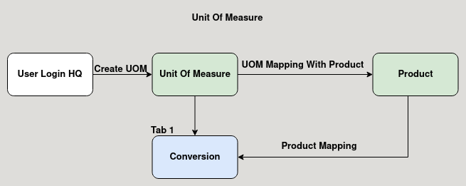

**Business Rules :**

* Unit of measure master is used to determine the quantity of a product.
* User can create unit of measure in HQ only.
* Once the unit of measure is created it is mapped with the product.
* The conversion tab is used to add the product to wich it is converted.
* When using the mapped product in transactions it is automatically converted to the conversion rate mapped in the unit of measure conversin tab.